# **Electrostatics**

## **Fundamental Forces (strong to weak):**

1. Strong Nuclear Force
   1. really short distance
   2. holds positive protons together
   3. breaking of this in fission (produces immense amounts of energy)
2. Electromagnetic Force
   1. Positive and negative
   2. Repels the same charge
   3. attracts opposite charges
   4. We don’t feel because most matter is neutral
3. Weak Nuclear Force
   1. Fusion
   2. Involves beta decay
4. Gravity

Atoms: neutral (same number of electrons and protons)

The Electrostatic force is $10^{45}$ times stronger than gravity! (but we don’t feel it because atoms are neutral)

**Electric charge is conserved!**

Transfer charge through **conductors**: make an even distribution of positive/negative charge. **Insulators** do not allow this transfer of charge. **Semiconductors** can sometimes be a conductor and sometimes be an insulator.

Charges on a conductor freely move around, while charges on an insulator don’t. **Only electrons move around; protons are fixed,** so only negative charges shift.

The ground has an infinite supply of charges.

Coulomb’s Law: $f=k\frac{Q_{1}Q_{2}}{r^{2}}$ where $k=\frac{1}{4πϵ_{0}}$ and $ϵ_{0}=8.85×10^{-12}{ C}^{2}/Nm^{2}$ (use absolute values)

An elementary charge is of an electron: $e=1.6×10^{-19} C$

The force on one charge is exactly the same as the force on another charge: newton’s second law. This is handy for drawing “**electric fields**”

* $E=\frac{F}{q}=\frac{1}{4πϵ_{0}}\frac{Q}{r^{2}}$ where $F$ is the force on the test charge and $q$ is the test charge
  + Useful to find forces for any charge: $F=qE$
* This basically takes the test charge out of Coulomb’s Law
$[E]=1\frac{N}{C}=1\frac{volt}{meter}$

* Electric field lines point to where positive charge will go
  + negative charges move against arrows
  + separation between lines indicates the magnitude of the charge (closer = stronger)
  + this electric field is still empty space!
  + lines **never cross!**
* Principle of Superposition:
  + Look at separate charges and add their *vectors* up to get the resultant charge
* Point charge
  + Causes a sphere of charge going outward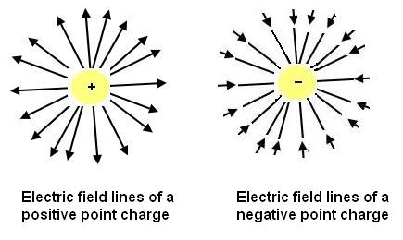
  + Two point charges create a field
    - 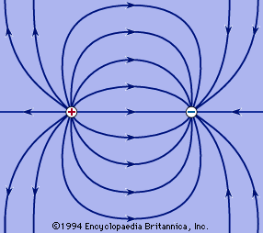
    - The only line on this field that doesn’t go to the negative charge is on the radial line
  + Same charge:
    - 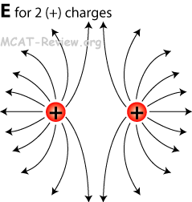
* Line of charges
  + Homogenous field (parallel field lines) pointing in/out
  + always perpendicular to surface!
  + same magnitude at any point
* Electric field used to deflect ink/electrons in CRT displays and inkjet printers
* EXAM QUESTION: CRT Displays
* *Insulators become conductors if you add enough charge*
* *on a conductor, only draw excess charges: everything else doesn’t matter*

Electric Fields in conductors:

* Charges move to the outside
* no field inside a conductor
* electric field is perpendicular to the surface

Conductor in an electric field:

* The charges in the conductor will move, creating no electric field inside the conductor itself!
* If there’s a hole in the conductor: **farday cage** (shields from charges)

## **Electric Flux**

* The number of electric field lines crossing an area
  + 1 field line per Coulomb
* Depends on angle from perpendicular ()
* + dot product!
  + If they are in the same direction, we can just pretend they aren’t vectors
* The shape of the are doesn’t matter: it depends on the area we are trying to calculate
* For odd shapes, we must integrate:
  + $\int{}\vec{E}d\vec{A}$ (choose A perpendicular to E to make the vector easier to calculate)
  + Closed surface: $\oint{}\vec{E}d\vec{A}$ (still integrate normally)
* The surface is *not* a physical object: it is a mathematical construct
* Positive field line: into surface; negative field line: out of surface
* **Field lines start and end on a charge** (with the exception of magnetism)

## **Gauss’ Law:**

* $Φ=\oint{}\vec{E}d\vec{A}=\frac{Q_{enclosed}}{ϵ_{0}}$ (simpler formula for finding charge)
* Solves for the total electric flux through a closed surface
* $\vec{A}$ is a vector that is perpendicular to the surface with magnitude equal to the area
* flux ~ charge (twice the flux, twice the charge)
* field lines that just go in/out don’t contribute to flux: only if a charge is inside!
* Use a **closed area** (“Gaussian Surface”) that is symmetric to the flux so that:
  + $\vec{A}$ is in the same direction as $\vec{E}$
  + The magnitude of $\vec{E}$ is the same everywhere on the surface
* This makes Gauss’ law: $Φ=E\oint{}dA$ (just E times the area of the surface)
* This can be used to find Coulomb’s law for a sphere
* Outside charges don’t matter as long as *nothing breaks the symmetry*

**Sphere:**

$4Eπr^{2}=\frac{Q_{enclosed}}{ϵ_{0}}$

* Point charge
* Lightbulb

**Cylinder:**

* Use $λ=\frac{Q}{L}=\frac{charge}{length}$ (charge density) instead of charge (so $Q_{enclosed}=λL$)
$E=\frac{λ}{ϵ_{0}2π}⋅\frac{1}{r}$

* Rearranging this gets $E=\frac{Q_{enclosed}}{2πrϵ_{0}L}$ (for a length)
* Rod/cylinder
* Length cancels
* Drops slower than a point charge! ($\frac{1}{r}$)
* Inside a cylinder (insulator only): $E=\frac{rλ}{2πϵ_{0}R^{2}}$ ( $R$ is the larger radius)
* Florescent Light

**Rectangular:**

$Elw=\frac{Q_{encloosed}}{ϵ_{0}}$

* sheet of light
* E is Constant!!! Only depends on how much area you’re looking at
* Does *not* depend on the radius!